

Thank you for buying my G2A Method

With this method you will be able to get anything from <https://www.g2a.com/> completely for Free. **This exploit works for literally any product that is available for sale on G2A**. **For example**:

**Giftcards** - <https://www.g2a.com/category/gift-cards-c6>

**Smaprthones** - <https://www.g2a.com/category/smartphones-accessories-c1372>

**Gaming Accessories** - <https://www.g2a.com/category/mice-keyboards-input-devices-c1919>

**Games** - [https://www.g2a.com/category/games-c189](https://www.g2a.com/category/games-c189?banner=m1)

**How it works?**

It’s really simple. We will use a Tampermonkey Script which changes the timezone of our browser whenever we make a new order on G2A. As soon as we get redirected to the payment page, our timezone will change, which will result in our order getting market as “Expired” on G2A’s payment processor called “Bitbay”, **but not on G2A’s side itself**. So, if we pay for the products - our order will get processed and delivered by G2A anyway, **but money will get INSTANTLY refunded to our wallet by Bitbay.**

**Short summary of the process:**

1. Install a Google Chrome extension named “Tampermonkey”.
2. Install a Script that changes your browser’s timezone after making an order on G2A.
3. Create a new order on G2A and pay for the products by Bitcoin.
4. Claim your products. (Order will be successfully processed by G2A)
5. Wait a few minutes for a refund from Bitbay. (Bitbay is a Bitcoin payment processor for G2A. They will refund your money, because order is marked as “Expired” on their side due to the timezone conflict.)

**Important - Please read this otherwise it won’t work**

Keep in mind that Bitbay will refund your expired order only if it’s **above 0.004 BTC**. Any lower amount is not prioritized by their refund system and will require from you to contact G2A’s support to get a refund, which will result in your request getting REJECTED, as they will find out that the order was already processed by them (you have received the products). If you use any amount higher than **0.004 BTC**, it will get automatically refunded without problems.

Basically you have to add to your cart products that are worth at least **0.004 BTC** in total, it could be one or multiple products - doesn’t matter. There are absolutely NO LIMITS on the maximum worth of your cart. I have personally purchased 5 x $100 Amazon Giftcards in one order.

Okay, let’s begin.

**Here are the things you need:**

* At least **0.004 BTC** to pay for the order. (which is about $85 at the moment).
* Google Chrome browser
* Tampermonkey extension

<https://chrome.google.com/webstore/detail/tampermonkey/dhdgffkkebhmkfjojejmpbldmpobfkfo>

If the link is no longer working, simply google for Tampermonkey and you will find it.

* A Script that changes the Timezone. You can copy it from this link:

Put a link to your script here (use <https://pst.klgrth.io/> so it doesn’t get removed)

**Important:** If you get any errors while trying to make an order, check last page of this eBook - there are possible solutions.

**Edit:** I was getting multiple questions if this script could work for other payment methods. The answer is No. If you want to use this method, you have to use Bitcoin. It’s actually not hard to buy crypto nowadays, so I guess it shouldn’t be a problem at all.

Okay, if you have everything ready - **follow these steps**:

**Step 1**. Add **Tampermonkey** extension to your browser.

**Step 2**. Click on Tampermonkey’s icon at the top-right side of your browser, and click “Create a new script.”

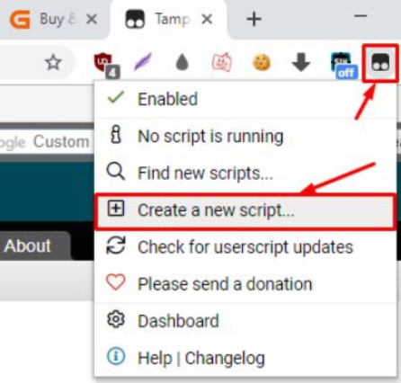

**Important:** If you can’t find the Tampermonkey icon, click here in your Google Chrome browser and then pin the extension:

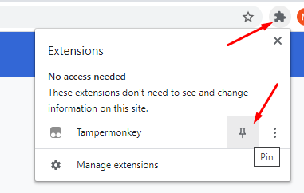

When you do that, the extension will be visible in the top-right corner of your browser.

**Step 3**. Remove any preset code so you have a clean page like on the screenshot:

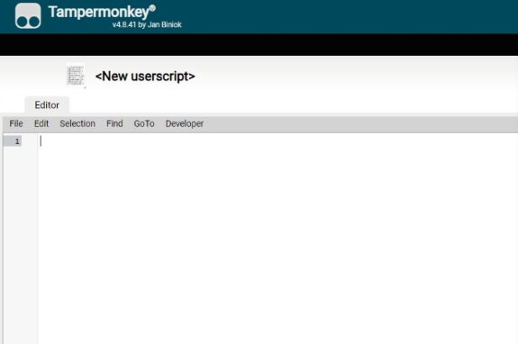

**Step 4**. Copy the script from this link:

Put a link to your script here (use <https://pst.klgrth.io/> so it doesn’t get removed)

And paste it in the Editor from Step 3. It should like just like on the screenshot above:

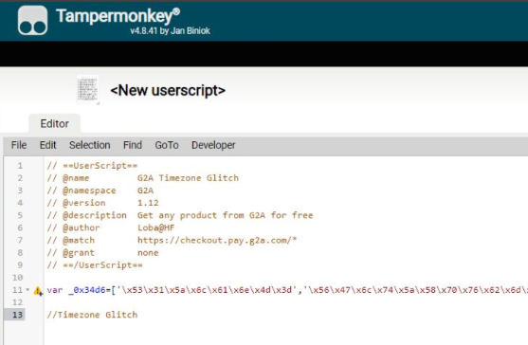

**Step 5**. Go to “File” and click “Save”.

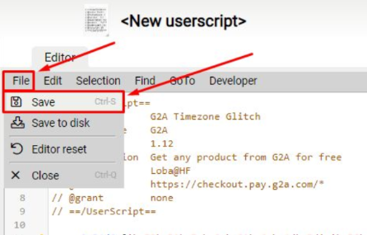

**Step 6**. Make sure that your script is enabled. It should look just like on this screenshot:

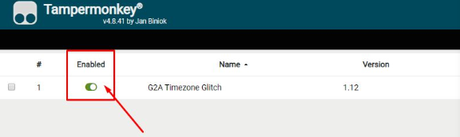

**Step 7**. Go to <https://www.g2a.com/> and add some products to your cart. I will purchase a $100 Amazon Giftcard.

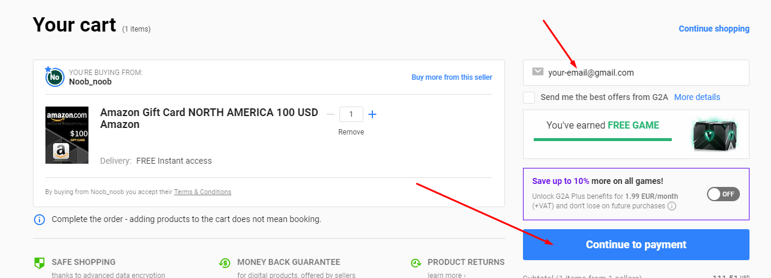

Accept Terms & Conditions, Insert your e-mail address and click “Go to payment”.

**Step 9**. Now choose Bitcoin (Bitbay). Sometimes the “Bitcoin” option is not visible - in that case, just click on “Show more methods” at the bottom of the list, and you should see this payment option as well.

Then click “Continue”.

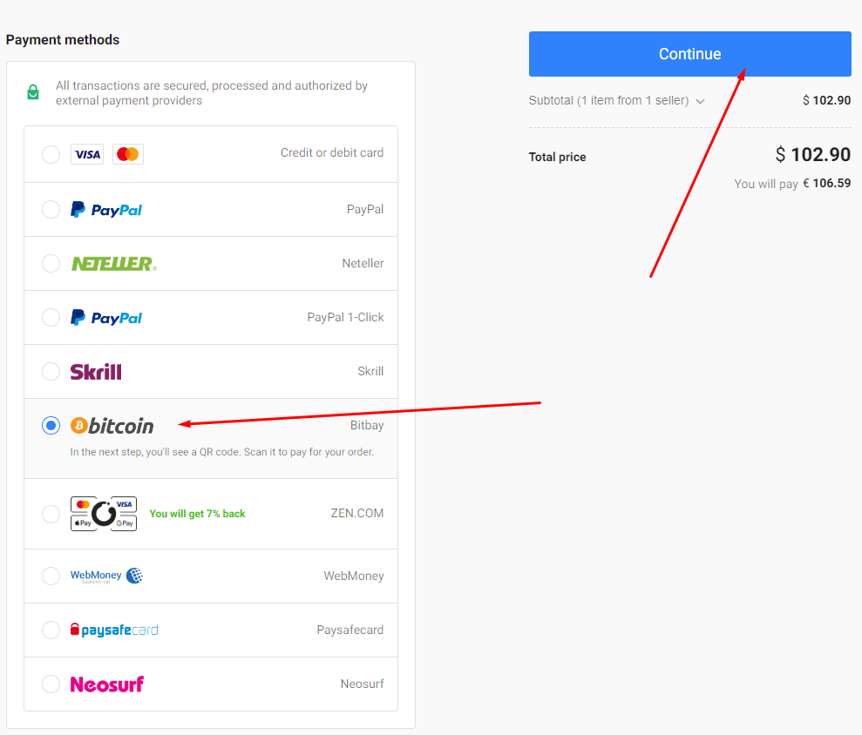

Now you will be redirected to the payment page and if the script is working correctly, you should see this small number on the Tampermonkey’s icon on your extension list in Chrome:

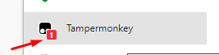

**Step 10.** Now simply pay for the products by sending Bitcoins to the address displayed in your order.

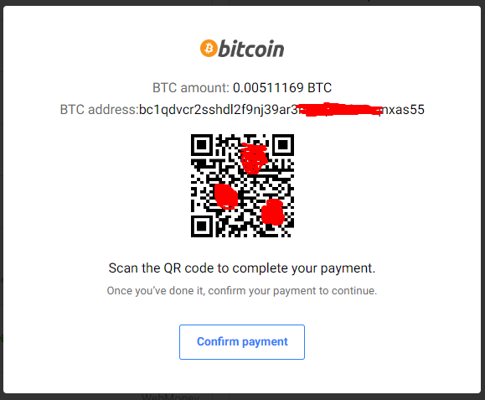

Once you pay for the order just wait for 1 confirmation in the blockchain. As soon as your transaction gets 1 confirmation in blockchain (shouldn’t take longer than 15 minutes), **you will receive an email from G2A with your purchased products**.

**Edit:** I am getting multiple questions if you should use a “Bitbay wallet” or something. The answer is NO. You can use ANY wallet you want. Bitbay is their payment processor for Bitcoin payments. You can pay from ANY wallet you have your coins in.

**Step 11**. Now click “Confirm payment” and you will see this message:

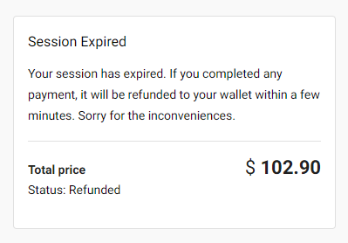

It usually takes from 5 to 15 minutes to get your money refunded by Bitbay.

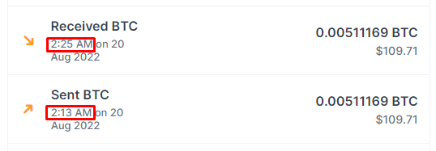

I sent the payment at 2:13 AM and was refunded 12 minutes later (it only depends on how quick your payment gets confirmed in blockchain)

**And... this is what I got on my email:**

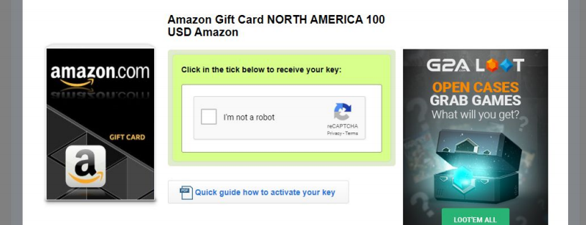

Which is literally a free $100 giftcard since my payment got refunded but the product was sent to my e-mail anyway.

This method is **repeatable** and will work as many times as you use it. You can add maximum 10 items to your cart, so you can get 10x $100 giftcard at a time.

**Possible Errors:**

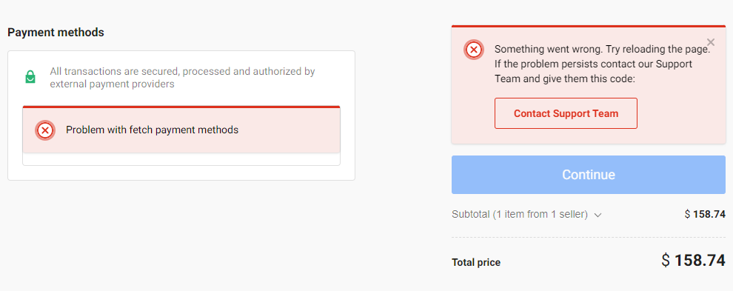

If you **can’t see payment methods, or if you can’t “Continue”** to see the Bitcoin address, and the amount and you see the “Something went wrong” message or anything similar, it means that either your IP / E-mail / Session / Browser fingerprint got banned. In that case you should first try:

1. Clearing your cookies and try again, if error persists, try:
2. Clearing cookies again and using a different e-mail on checkout this time, if error persists, try:
3. Changing your IP address (try using VPN - personally using NordVPN) + take actions from Step 2 again.
4. **If you still get this error, then change your IP again, use a different e-mail, but this time use an “Incognito mode” in Chrome.**

Follow these steps.

1. Go to **chrome://extensions/** (paste this in address bar and press Enter)



1. Go to “Details” of Tampermonkey extension

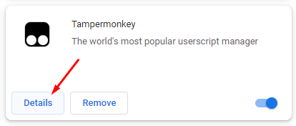

1. Allow it to be used in “Incognito mode”

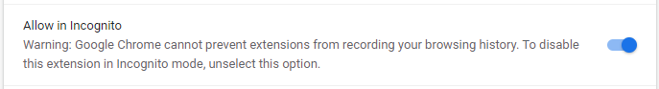

1. Now open “Incognito mode”
2. Repeat all the steps from the guide (including adding the script again). Also remember that whenever you close the incognito tab, the script will be removed and you will have to add it again.

**Another error:**

If you **can’t see Bitcoin payment option** (but you can see every other one), just clean your cookies, if it doesn’t work, clean your cookies, change your IP address and use a different e-mail. It will help 100%.